
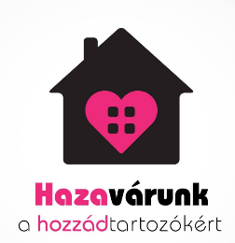
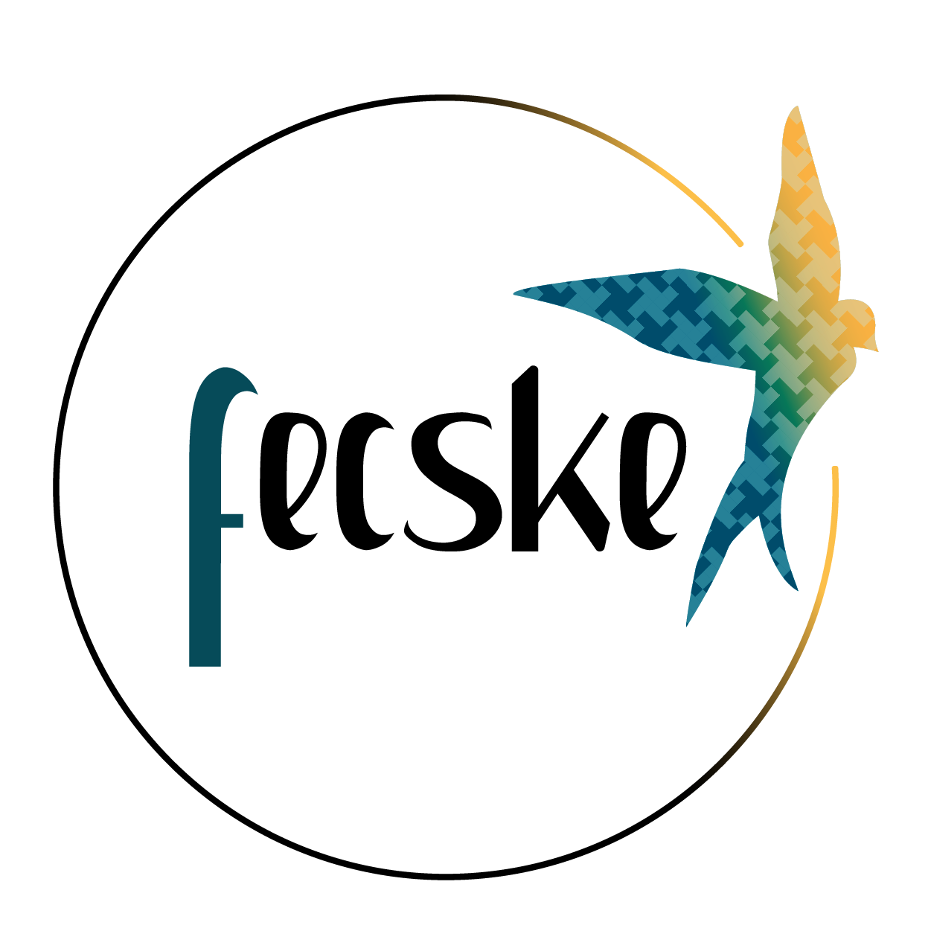

Comments on Draft General Comment No. 27 (202x) on children’s rights to access to justice and effective remedies
Joint submission by the Support Network for Detainees and their Families (FECSKE), the Hazavárunk Foundation (HF) and the Hungarian Helsinki Committee (HHC)
Budapest, 23 August 2024

Introduction
1. We, the coalition of three Hungarian civil society organisations, welcome the opportunity to support the UN Committee on the Rights of the Child (the Committee) by contributing to the drafting of its General Comment No. 27 on children’s rights to access to justice and effective remedies by shedding light on issues related to the situation of children affected by parental imprisonment and parental involvement in justice processes. We come together as a coalition of civil society organisations in an environment where the state does not encourage or promote the contribution of CSOs in supporting people affected by the criminal justice system. There is little or no societal awareness of the (unintended) harms associated with imprisonment, which place a heavy burden on families and especially on children with imprisoned parents. The three CSOs contributing to this document work to address these issues through
- Providing services and support to affected children and their caregivers, including legal empowerment;
- Raising social awareness to de-stigmatise their life situation by providing authentic information on the negative impact of policy gaps on children;
- Engaging in advocacy and strategic litigation efforts to persuade authorities to respect children’s rights to direct and continuous contact with their parents under Article 9(3).
2. The Support Network for Detainees and their Families (FECSKE) is an informal civil society empowerment and advocacy network of (formerly) incarcerated people and their families, members of civil society, supporters of people in prison, as well as academics and professionals who work together for a fair and humane prison system in Hungary. The members of FECSKE—including about 25 families—believe that children and family members have the right to maintain quality contact with their imprisoned relatives. Hazavárunk Foundation (HF) is a civil society organisation working in the field of child protection and has been providing various services to children with a parent in prison for over a decade. HF’s work, which is primarily based on the work of volunteers, focuses on alleviating the heavy burden of parental imprisonment on children and their carers, supporting children who have a parent in prison and helping them to maintain and strengthen their relationship with their incarcerated parent. They support around 70 disadvantaged families with children affected by parental imprisonment. The Hungarian Helsinki Committee (HHC) is a leading human rights watchdog in Hungary with significant influence in the field. It is the only civil society organisation that provides free legal aid to people affected by imprisonment. Its Criminal Justice Programme receives around 500 complaints a year from prisoners and their families about substandard prison conditions. HHC ran a prison monitoring programme for more than two decades, between 1995 and 2017. During this period, the organisation carried out 1,237 monitoring visits to police jails, 48 visits to penitentiary institutions and 51 inspections at immigration detention facilities. The HHC regularly submits communications to various international forums (CPT, UNWGAD, SPT, UPR, etc.) on related issues, including monitoring the implementation of judgments of the European Court of Human Rights (ECtHR). HHC lawyers have successfully litigated a number of cases related to prison conditions and treatment—including severe restrictions on visits—in Hungarian prisons before domestic forums and the ECtHR. The HHC is one of the founding members of FECSKE and a member of the Children of Prisoners Europe (COPE) network.

Definitions and understandings of access to justice and effective remedies for children
3. It is estimated that approximately 52,000 children in Hungary experience the incarceration of a parent on criminal charges each year. The most significant issue regarding children’s access to justice and effective remedies is that the relevant authorities and law enforcement agencies, such as the National Penitentiary Administration (NPA) and the police, largely disregard children as rights holders in their practice. As a result, children are not informed of their rights. Furthermore, law enforcement officials are not adequately trained to deal with children in situations where a parent is facing criminal proceedings or when children visit their parents or other family members in prison.
4. In HHC’s experience, families often don’t receive a response from prison commanders to their written requests, for example, for a family visit in which children can participate and have physical contact with their imprisoned parent. In addition, the NPA often uses a stigmatising argument to justify severe restrictions on visits, claiming that children are used by adults upon visits to smuggle prohibited items into prisons.

Barriers preventing children from gaining access to justice and effective remedies
5. The General Comment should call upon State parties to reverse policies that undermine children’s access to justice and marginalise vulnerable groups of children. Unlawful practices of parental imprisonment undermine children’s dignity, equality and non-discrimination and can lead to stigma, disempowerment and isolation. Children face systematic violations of the right to contact with their incarcerated parent (Article 9), as well as other rights under Articles 2, 3, 12, 16, 18, 19 and 26.
6. Our experience is that children imprisoned parents are surrounded by intersecting socio-cultural and financial barriers, and they often face discrimination and social exclusion.
7. As in many other countries, children in Hungary suffer systemic violations of their right to contact with their parents in prison. Although Hungarian prisons are required by law to promote and support the maintenance of family relationships throughout the period of imprisonment, they largely neglect their duty to do so. Family visits—the only form of visitation where children can have continuous, direct contact with the parent they are visiting—are severely underused. Between January 2023 and March 2024, there was one month when none of the prisons organised family visits, with a prison population of around 18-19,000. In the best month, March 2024, 279 prisoners, or 1.5% of the prison population, received visits from their children.
8. The NPA tends to ignore the best interest principle, which may discourage children from participating in visits. The NPA operates with serious capacity problems and does not pay special attention to visiting children. In addition, opportunities to spend meaningful time that fosters the child-parent bond are largely lacking. Furthermore, according to professionals, prison staff lack adequate training, and there are no minimum professional standards for the treatment of visiting children.
9. One of FECSKE’s members, a father suspected of a non-violent crime, spent almost a year in pre-trial detention in 2022-2023 and decided not to let his two children visit him, because the conditions would have been too traumatic for them. The children were both under the age of 8, one of whom is neurodivergent. The prison had not informed any family members of the availability of family visits for detainees with children, and he had not encountered such a visiting facility in the prison where he was being held. He and his wife agreed that it would have been completely inappropriate and upsetting for the children not to be able to touch their father during visits.
10. The HHC is regularly contacted by families where the NPA does not respect a child’s bond with an imprisoned family member: child-friendly family visits are not available to them because the relationship is not legally parental (thus also excluding children of LGBTQ parents). According to the rules on visits, children cannot participate in visits without physical separation if their grandparent, uncle, or aunt is imprisoned.
11. Another example of harmful policies that disregard children’s rights in Hungary is the petty offence fine imposed on parents for their children’s truancy, which, among other petty offences, can lead to imprisonment. Such policies have dire effects on indigent families, disproportionately affecting ethnic Roma minorities. As a result, they often face multiple disadvantages as exclusionary policies affecting different social vulnerabilities intersect with each other, such as gender, class, and ethnicity. If children are unjustifiably absent from more than 30 lessons in a school year, their parents receive a fine of approximately HUF 100-150 thousand (EUR 250-300). Poverty-stricken families are unable to pay such fines, which are converted into prison sentences at a daily rate of HUF 7500 (around EUR 20). It is clear that this policy only exacerbates the intersectional disadvantage faced by these children and does not result in them receiving a better, more meaningful education. In addition, the Hungarian legislation also allows for juveniles to be subjected to petty offence confinement, contrary to Article 37 of the Convention, which must be carried out in penitentiary institutions instead of juvenile reformatories, contrary to the Beijing Rules.
12. In HF’s experience, children and their caregivers—primarily women—most often do not ask for help with the problem of having a parent in prison because of the shame and stigma attached to their situation. When they do, they usually signal a problem different from the central one—that the breadwinner is in prison. Few children and families have access to timely and effective remedies, perpetuating cycles of discrimination and exclusion. Access to justice is therefore crucial to addressing inequalities and discrimination and enabling children and families to reclaim their denied rights.
13. Most of the prison population is men, the primary income earners in many families. HF’s experience shows that the imprisonment of a parent places an enormous financial burden on affected families, who already have limited access to support services. Imprisonment exacerbates the underlying problems that already make life difficult for the family and, in the absence of specific support from the state, pushes already impoverished families further down the road to extreme poverty. In addition to losing a whole income, the costs of imprisonment are largely borne by the family outside: phone calls are three times as expensive as outside, sending parcels with essential items and additional food also represents a significantly higher cost than outside, lawyers’ fees much too high for impoverished families, etc. At the same time, the families with children experiencing parental imprisonment are themselves in need of support both financially and emotionally. Parental imprisonment is one of ten Adverse Childhood Experiences (ACEs). It is therefore vital that programmes are put in place to mitigate the further effects of poverty, marginalisation, discrimination and social exclusion on these children.

Enabling factors and strategies: the role of CSOs and technology
14. State parties should be encouraged to support CSOs’ operations in providing services that promote and protect children’s rights. A good CSO practice is HF’s “Package from Dad programme,” a service that strengthens the child-parent bond: the parent tells them what the child likes, and accompanied by his/her letter, the Foundation sends a personal gift for the child on a special day (birthday or Christmas).
15. “It takes a village” to support children: holistic, multi-sectoral cooperation must be promoted among stakeholders, especially State agencies and CSOs. State parties should be encouraged to foster cooperation with CSOs in children’s interests. In 2017, the NPA unilaterally terminated its cooperation agreement with most CSOs providing various services in prisons. Since then, the penitentiary system has become even more closed off from society, with security considerations overriding human rights concerns. The NPA essentially regards cooperation with CSOs as a severe risk factor.
16. The role of technology keeps increasing in the Hungarian system, as it does worldwide. Since the COVID-19 pandemic, Skype-based video communication has become a regular practice of keeping in contact with family members, including children outside prison walls. However, our research and experience show that the NPA tends to push personal contact into the online sphere—because it is “safer” and decreases their workload. Keeping contact through online tools is a commendable additional option; however, maintaining contact online should never replace personal visits—especially when children are involved. According to HF’s experience, children become even more distanced from the absent parent, essentially limiting contact to the sphere of verbality, which for most children and their imprisoned parents is not a familiar form of self- and emotional expression.

Best interests considerations and training of professionals
17. This General Comment should encourage State parties to foster awareness-raising among professionals working with law enforcement agencies on how to employ the best interest of the child principle in all decisions concerning children. Similarly, children would benefit from the multi-agency cooperation of stakeholders in addressing their shared responsibilities that affect children's enjoyment of their rights, access to justice, and effective remedies. Mutual training and knowledge sharing are also essential in filling existing gaps in this regard. The criminal justice chain as such, in addition to education professionals, health- and social service agencies need to work together so that children in vulnerable situations do not fall through the cracks of existing service gaps caused by welfare and criminal justice silos. In this respect, State parties should be encouraged to utilise the guidance provided by the landmark Council of Europe Recommendation CM/Rec(2018)5 concerning children with imprisoned parents.

Outcome and impact of the remedy
18. Establishing independent monitoring bodies in State parties with the active involvement of CSOs can contribute to shifting practices toward complying with international standards, recommendations, and best practices. Involving civil society is crucial for the monitoring bodies to be entirely independent of the State. This becomes particularly pronounced in situations where the rule of law backsliding undermines the intended functioning of the national human rights institution.
19. State parties should be encouraged to build consolidated, cooperation-based relationships with CSOs. However, if the authorities show little to no openness to cooperation, continuous advocacy and strategic litigation can still lead to positive structural change. One example is tackling the severe restrictions prohibiting physical contact between detainees and their visitors during the general form of visits, i.e. “group visits”, imposed by the NPA in 2017. Visiting children were also not exempted from the ban on physical contact during group visits, meaning that they were not allowed to touch their detained parents. Along with another lawyer, an HHC lawyer brought this issue to the ECtHR, which, in a 2023 landmark judgment, established that the practice of separation using a glass partition in Hungarian detention facilities was a matter of routine rather than a reaction to any specific security risks, as the “authorities confined themselves to a perceived general need to preserve the safety of prisons and introduced an overall ban on physical contact”.

The abbreviation FECSKE means the bird swallow in Hungarian, https://www.fogvatartas.hu/.
Hazavárunk means “We welcome you home” in Hungarian, https://www.hazavarunk.hu/.
https://helsinki.hu/en/activities/justice/.
Figure based on an extrapolation by COPE using a rate of 1.3 children per male prisoner in European countries to estimate the number of children affected, based on a 1999 study by the French Institute for Statistics, INSEE source: Children of Imprisoned Parents: European Perspectives on Good Practice, p. 15.
Section 164(6) of the Act CCXL of 2013 on the Execution of Punishments, Measures, Certain Coercive Measures and Petty Offence Confinement (Penitentiary Code).
Order 20/2024. (VII. 12.) of the NPA.
Response no. 30500/2587-7/2024 issued by the NPA to the HHC’s Freedom of Information (FOI) request on 31/05/2024.
Response no. 30500/5563-7/2023 issued by the NPA to the HHC’s FOI request on 04/12/2023.
In Hungary, children under 16 are required to participate in compulsory education according to Section 45(3) of the Act CXC of 2011 on National Public Education.
Act II of 2012 on Petty Offences, the Petty Offence Procedure, and the Petty Offence Registry System, Sections 12, 15 and 23.
See, e.g. Radio Free Europe Hungary’s investigative report “Debtor’s prison” here with English subtitles: https://www.youtube.com/watch?v=Zdx-oT0p16M.
Submission of the Justice and Rule of Law Programme of the Hungarian Helsinki Committee for the periodic visit to Hungary by the European Committee for the Prevention of Torture and Inhuman or Degrading Treatment or Punishment (CPT), March 2023, available at: https://helsinki.hu/en/wp-content/uploads/sites/2/2023/ 09/HHC_CriminalJustice_CPT2023-web.pdf.
See: https://childrenofprisoners.eu/wp-content/uploads/2019/09/ACEs_briefing.pdf.
See, e.g. Stillman, S. (2024), Do Children Have a “Right to Hug” their Parents? The New Yorker.
See HHC’s Factsheet on contacts with the outside world.
Kovács, P., Krámer, L., & Szegő, D. (2021), Keeping in Contact in Hungarian Penitentiaries. FECSKE.
Hungarian Helsinki Committee, Rule of Law Backsliding in Hungary From a Criminal Justice and Law Enforcement Perspective, January 2023, available at: https://helsinki.hu/en/rule-of-law-backsliding-from-a-criminal-justice-perspective/.
Takó and Visztné Zámbó v. Hungary, Applications nos. 82939/17 and 27166/19, §14.

